COMP3005, application usage explanation: Fitness management system

All the required files are listed in the github link: <https://github.com/lsobh093/Comp3005Project.git>

The application was developed the java programming language, using IntelliJ IDEA 2024.1 using resources from: (ensure that you have the maven extension installed as well)

https://www.postgresqltutorial.com/postgresql-jdbc/

In addition to the files mentioned (java and SQL), the user should have access to pgAdmin 4 to load and interact with the DDL, DML, and the rest of the SQL files.

Instructions to interact with the java application:

1. Load the provided DDL and DML files into pgAdmin 4
2. The user should also load the provided trigger functions, and the constructed Views for complete functionality.
3. All the functions are abstracted away into subclasses, therefore the simplest way to run the application is to save all the Java files into 1 folder and load that folder into IntelliJ IDEA 2024.1.
4. “Run” the Main.java file, which will provide the user with some options:

Main Menu:

1. Login as Member

2. Login as Trainer

3. Login as Staff

4. Register as a Member

5. Exit

Please enter your choice:

Pre-defined data (from the DML) have been provided to test-run the application. For example, some pre-registered members, trainers, and staff administrators have been provided. (Check out the adminuseraccounts, traineruseraccounts, and memberuseraccounts tables for logging into the application). Each entity has specific functions, which can only be viewed upon logging in.

1. The user may also Register a new member into the database. However, at this time new trainers and staff administrators cannot register new accounts. The latter functionality can be easily integrated at any time.
2. The initial user interaction menu is handled through the java file: UserInteraction.java
3. Registering as a member, will prompt the user for personal information:

Member Registration

Enter your first name:

Cat

Enter your last name:

Dog

Enter your date of birth: (YYYY/MM/DD):

1989-07-26

Enter your gender:

female

Enter your address:

123 Main street

Enter your email:

12347catdog@gmail.com

Enter your phone number:

613-098-3456

Enter your emergency contact name:

Elephant

Enter your emergency contact phone number:

613-098-1234

Member registered successfully! Please create a username and password!

1. The data is initially saved into the database through the use of POSTGRESQL codes, where they are give a new unique memberID. The member is then prompted to enter a unique username and password to complete their account creation.

Member Registration Snippet:

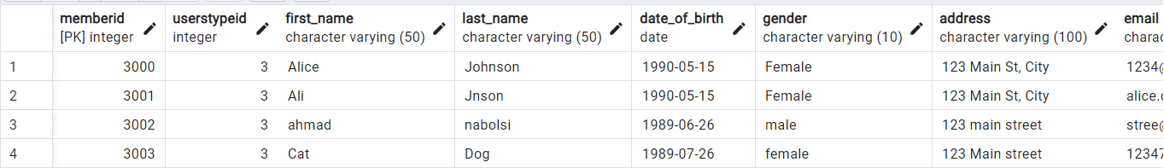

Member username and password storage: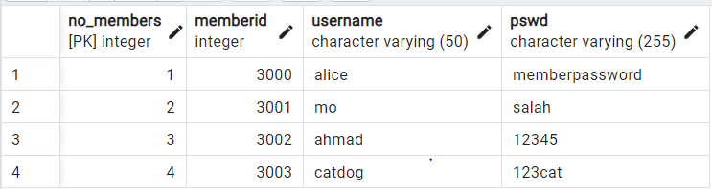

1. The application tests if the username is already used or not.
2. The user is then given the following options:

Welcome Member with ID: 3003

Please select from the following options:

1. View Gym Memberships to Purchase.

2. Manage Profile (update personal information, fitness goals, and health metrics).

3. Dashboard Display.

4. Schedule a group fitness class.

5. Schedule a private session with a trainer.

6. Exit from the system.

Enter your choice:

The member can purchase a membership, Basic ($50.00) and Premium ($100.00). The difference between the two types is that premium members do not need to make a an additional payment to private sessions.

Enter your choice: 1

Available Subscriptions:

Subscription ID: 1

Subscription Type: Basic

Price: $50.0

-----------------------------------

Subscription ID: 2

Subscription Type: Premium

Price: $100.0

-----------------------------------

Enter the Subscription ID you want to purchase (1 or 2): 1

Subscription purchased successfully!

When a member makes a subscription/membership purchase an invoice is also generated in the process, which will appear as ‘Paid.’ However, the invoice will remain ‘Pending’ until an Admin Staff processes the payment. When an Admin Staff processes the payment, the subscription of the member will become ‘Active’ or true as shown below:

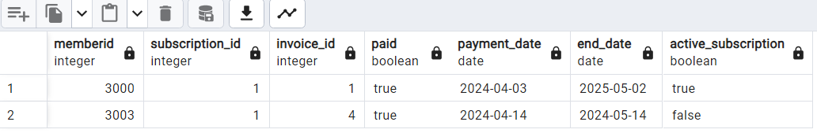

The member is not allowed to purchase another subscription if the end_date of the current subscription is larger than the current date (indicating that a subscription is still active). This is checked by the application.

Enter your choice: 1

Available Subscriptions:

Subscription ID: 1

Subscription Type: Basic

Price: $50.0

-----------------------------------

Subscription ID: 2

Subscription Type: Premium

Price: $100.0

-----------------------------------

Enter the Subscription ID you want to purchase (1 or 2): 1

You already have an active membership

1. The member can update their information and password through ‘Manage Profile’ option.
2. Manage Profile also allows the user to set personal goals and enter health metrics.

Personal goals include:

1. Weight loss
2. Muscle gain
3. Maintain

The goal is set to end 1 week from the current date the user sets a goal. Each goal has specific calorie goal that is calculated for 1 week.

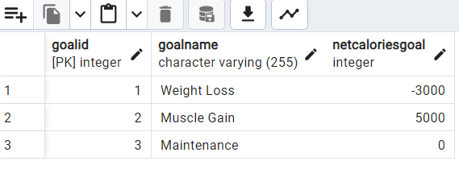

Therefore, this application aims to track all the work outs a user does (caloric loss), as well as the nutrition (caloric intake) (more on this later).

1. The member can also view their health metrics, if not present the application generates random data for various health metrics (weight, height, body fat percentage, etc…) (for illustration purposes). The application retrieves the most recently updated values by date.

Welcome to Profile Management:

1. Update Personal Information.

2. Update or view personal goals.

3. Update or view health metrics.

4. Go back to previous page.

5. Exit from program

Enter your choice: 3

No existing health metrics found for member ID: 3002

Do you want to add new health metrics? (yes/no): yes

New health metrics added successfully.

Would you like to display your health metrics or go back to the main menu?

1. To go back to main menu.

2. To display your health metrics.

3. To exit

Enter your choice: 2

Existing and Latest Health Metrics:

Date Recorded: 2024-04-14

Weight: 78.51 kg

Height: 150.0 cm

Body Fat Percentage: 13.42

Resting Heart Rate: 75 bpm

Blood Pressure: 134 mmHg

1. The Dashboard displays the workout routines, nutrition journal, health statistics, and achievements attained from the past 7 days (over the duration of the Fitness goal).
2. Viewing member’s exercise routines yields the following output from the dashboard:

View your workout routines (past 7 days)

2. View your nutrition journal (past 7 days)

3. View your health statics

4. View your achievements for the most recent goal

5. Go back to the main menu

6. Exit

Enter your choice: 1

Welcome to your exercise tracker

1. Enter Manual Data into your tracker

2. Display your routine exercises for the past 7 days

3. Go back to the previous page

4. Exit

Enter your choice: 2

This user has not entered any routines yet.

Welcome to your exercise tracker

1. Enter Manual Data into your tracker

2. Display your routine exercises for the past 7 days

3. Go back to the previous page

4. Exit

Enter your choice: 1

Please manually enter your workout data log for the day.

Enter the exercise type

Do you want to load the list of exercises and their code? (yes/no)

A new member will have any exercise routines, so they will have enter new data:

Do you want to load the list of exercises and their code? (yes/no)

yes

The list of exercises:

WorkoutID WorkoutName CaloriesBurnedPerMinute

---------------------------------------------------------

1 Running 10.50

2 Pushups 5.00

3 Swimming 12.00

4 Cycling 8.50

5 Weightlifting 6.00

6 HIIT 13.50

7 Walking 5.00

8 Jump Rope 10.00

9 Squats 6.00

10 Deadlifts 8.00

Please enter an integer selection (1-10)

Please enter an integer selection (1-10)

3

Enter the day and start time in the format YYYY-MM-DD H:mm

2024-04-02 9:30

Enter the day and end time in the format YYYY-MM-DD H:mm

2024-04-02 10:30

Enter the weight (kg) if applicable zero otherwise

0

Enter the number of sets if applicable zero otherwise

0

User workouts inserted successfully.

The data is now saved, and the trigger function calculates the duration and total calories burned (duration * calories burned per minute as given in the exercise list):

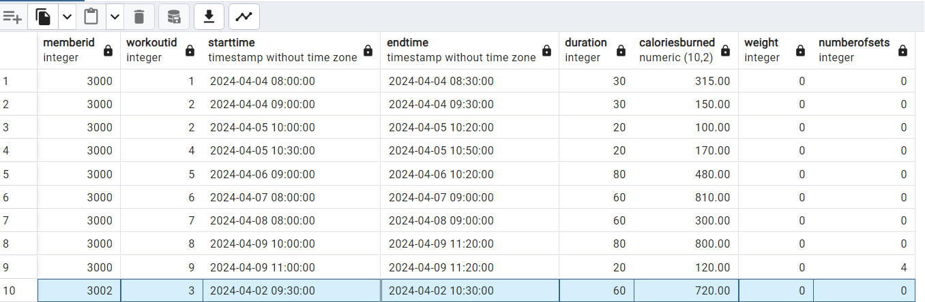

**The user can continue to add data simulating a Fitbit collecting and inserting data.**

The Dashboard will only print out the exercise routines for the past 7 days from the current date.

1. The application also tracks nutrition intake, by allowing the member to keep a nutrition journal:

Select one of the following options:

1. View your workout routines (past 7 days)

2. View your nutrition journal (past 7 days)

3. View your health statics

4. View your achievements for the most recent goal

5. Go back to the main menu

6. Exit

Enter your choice: 2

Welcome to your nutrition tracker

1. Enter Manual Data into your tracker

2. Display your nutrition entries for the past 7 days

3. Go back to the previous page

4. Exit

Enter your choice: 1

Enter meal information:

Meal Date (YYYY-MM-DD): 2024-04-12

Meal Description: fish

Calories: 56

Meal data inserted successfully.

The data gets updated into the database as shown below.

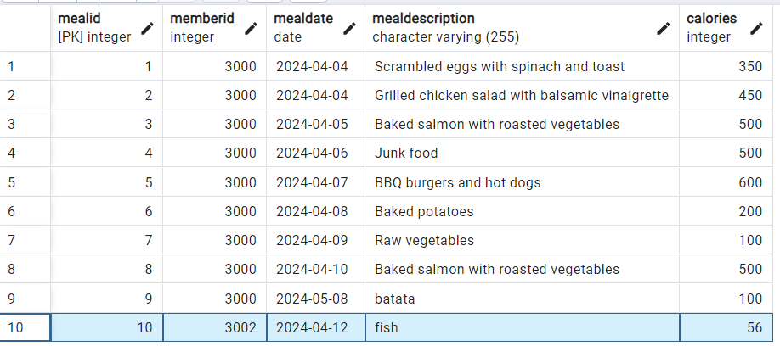

1. **Member Achievements** **are calculated by the application and then inserted into the ‘Achievements’ table!** The logic is handled by the code in the ‘MemberAchievements’ file. **Achievement can only be calculated if a user enters a Fitnessgoal, nutrition journal, and workouts!**

Achievements are determined over a 7 day period corresponding to the dates set by the member for their FitnessGoal. First the application calculates the Total calories burned and Total calories consumed, and compared to the total Calories from the Fitness goal.

1. View your workout routines (past 7 days)

2. View your nutrition journal (past 7 days)

3. View your health statics

4. View your achievements for the most recent goal

5. Go back to the main menu

6. Exit

Enter your choice: 4

Latest Achievement:

Achievement ID: 1

Member ID: 3002

Calories Goal: Not Reached, Keep Going!

Date Updated: 2024-04-13

1. There are two types of scheduling:

Scheduling for private sessions with a trainer and scheduling for a class. For demonstration, it is assumed that scheduling for classes is part of the membership, whereas scheduling for private sessions requires additional payments.

1. The DML files contains pre-loaded data such as a pre-set schedule by some trainers.

Class Registration is handled by the code in ‘Member Registration’ java file.

Welcome to class registration

1. View Class Schedule.

2. Register for a class.

3. View the classes that you are registered in

4. Go back to the previous page.

5. Exit

**In order to view the class schedule, you must load the VIEW file “ClassCalendarforMembers VIEW.sql”**

1. View Class Schedule.

2. Register for a class.

3. View the classes that you are registered in

4. Go back to the previous page.

5. Exit

1

===============================================================================================

Availability ID Room Name Session Type Trainer Status Start Time End Time Date Time Slot

===============================================================================================

7 Room B Class Emily Smith Available 11:00:00 12:00:00 2024-04-13 11:00:00 - 12:00:00

9 Room A Class Emily Smith Available 09:00:00 11:00:00 2024-04-15 09:00:00 - 11:00:00

11 Room D Class Michael Johnson Available 09:00:00 12:00:00 2024-04-12 09:00:00 - 12:00:00

13 Room C Class Michael Johnson Available 13:00:00 15:00:00 2024-04-14 13:00:00 - 15:00:00

===============================================================================================

Going back to menu